Volunteer Waiver / Release of Liability

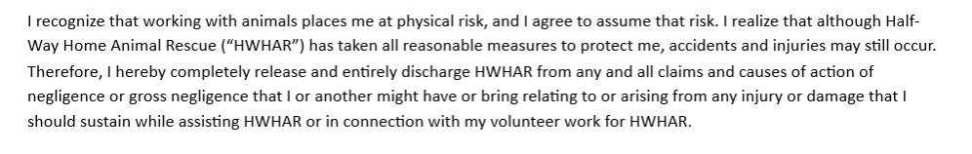
Understanding and acceptance of volunteer guidelines __________ Volunteer Initials

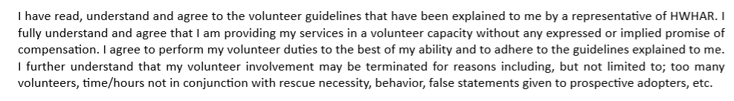
Photo Release

_______________________________ _______________________________ ____________
Volunteer Signature Volunteer Name (Printed Name) Date

______________________________ ______________________________ ____________
HWHAR Coordinator Signature Coordinator Name (Printed Name) Date

_______________________________ ______________________________ ____________
Parent / Guardian Signature Parent / Guardian (Printed Name) Date

Please provide contact information EMAIL: __________________________________________

_____________________________________ _______________________ __________________
Address City State / Zip Code

________________________________ ________________________________________________
Contact phone number (home / cell) If under 18 - Current Enrolled High School Name & City

